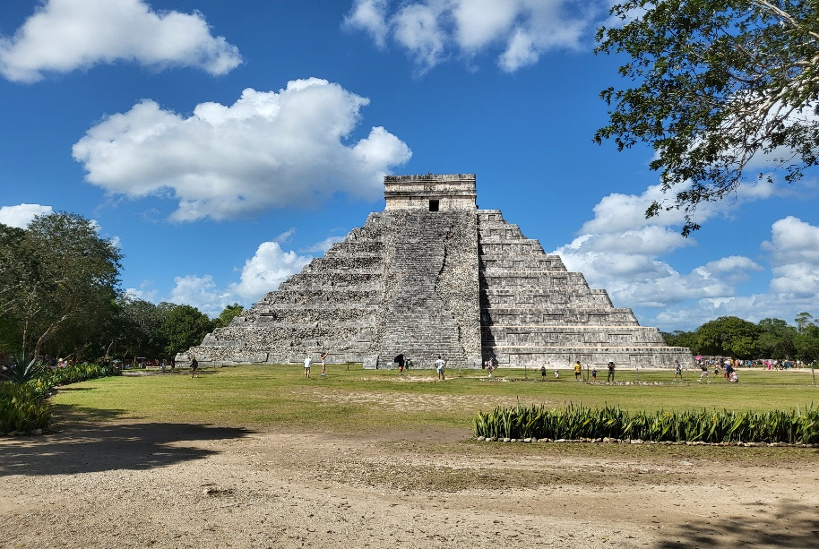

History of Chichen Itza

Chichen Itza is one of the most famous and well-preserved archaeological sites in Mexico, known for its impressive Mayan ruins. Here's an overview of the history of Chichen Itza:

**1. \*Early Occupation (c. 600 AD):\*** Chichen Itza was originally founded by the Maya people around the 6th century AD. The name "Chichen Itza" means "at the mouth of the well of Itza," referring to the natural sinkholes (cenotes) that provided a vital water source for the city.

**2. \*Mayan Influence:\*** Chichen Itza was influenced by Maya culture and traditions, but it also had significant interactions with other Mesoamerican cultures, particularly the Toltecs from central Mexico.

**3. \*Toltec Influence (10th century AD):\*** In the 10th century, Chichen Itza became a major political and cultural center in the Yucatan Peninsula. It is believed that the Toltecs, who had a powerful civilization in central Mexico, influenced Chichen Itza's architecture, art, and religious practices. This period saw the construction of many of the city's iconic structures.

**4. \*The Pyramid of Kukulkan:\*** One of the most famous structures at Chichen Itza is the Pyramid of Kukulkan (El Castillo), a step pyramid dedicated to the feathered serpent deity Kukulkan (equivalent to the Aztec god Quetzalcoatl). The pyramid is renowned for its precise astronomical alignment and the visual effect of a serpent descending the pyramid's staircase during the spring and autumn equinoxes.

**5. \*Decline and Abandonment (c. 10th century - 13th century):\*** By the late 10th century, Chichen Itza's influence began to wane, possibly due to a combination of factors, including drought, political instability, and conflict. The city was eventually abandoned, and its once-thriving urban center fell into ruins.

**6. \*Re-discovery and Archaeological Exploration:\*** Chichen Itza remained largely forgotten and hidden in the jungles of the Yucatan Peninsula until it was rediscovered by European explorers and archaeologists in the 19th century. Extensive excavations and restoration efforts began in the 20th century.

**7. \*UNESCO World Heritage Site:\*** Chichen Itza was designated as a UNESCO World Heritage Site in 1988 for its historical and cultural significance. It is also considered one of the New Seven Wonders of the World.

**8. \*Tourism and Preservation:\*** Today, Chichen Itza is one of Mexico's most popular tourist destinations, drawing visitors from around the world to marvel at its well-preserved pyramids, temples, ball courts, and other structures. Efforts continue to be made to preserve and protect the site for future generations.

Chichen Itza represents a fascinating blend of Maya and Toltec cultures and is a testament to the architectural and astronomical achievements of ancient Mesoamerican civilizations. It stands as a symbol of Mexico's rich cultural heritage and history.